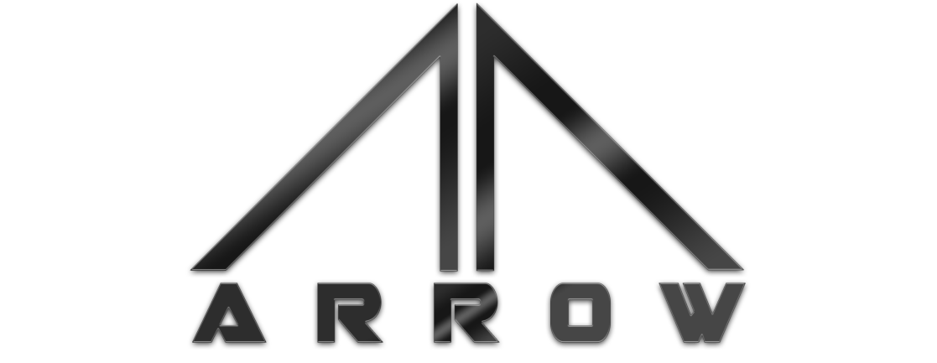Arrow Launcher Labyrith Studios

**Version: 1.0 Document Version: 1.0**

Thank you for purchasing the Arrow Launcher, the first dedicated, fully customizable application launcher for Unity.

Arrow Launchers can be built using ANY method you choose in Unity, we use the Unity UI system as it has proven to be the most powerful tool for both menus and other UI elements alike.

Arrow does not limit your launcher capabilities to a video game, or entertainment product, but can point to any executable in Windows and can be used to build a launcher or branding splash screen for any application or file.

Throughout this document, we will be covering the basics of creating a professional, borderless window in Arrow, automatically centring it and some basic UI features as well, to help you build your launcher, if you feel as though we have left something out or would like to know more about Arrow, feel free to contact us at our [Contact](http://www.labyrith.co.uk/contact-us/) page.

As shown in the next few pages, Arrow can be used to produce or replicate an almost unlimited number of styles, you are only limited by what you can put into the Unity UI.

Examples of Design

These are just a few of the styles we have created using Arrow.

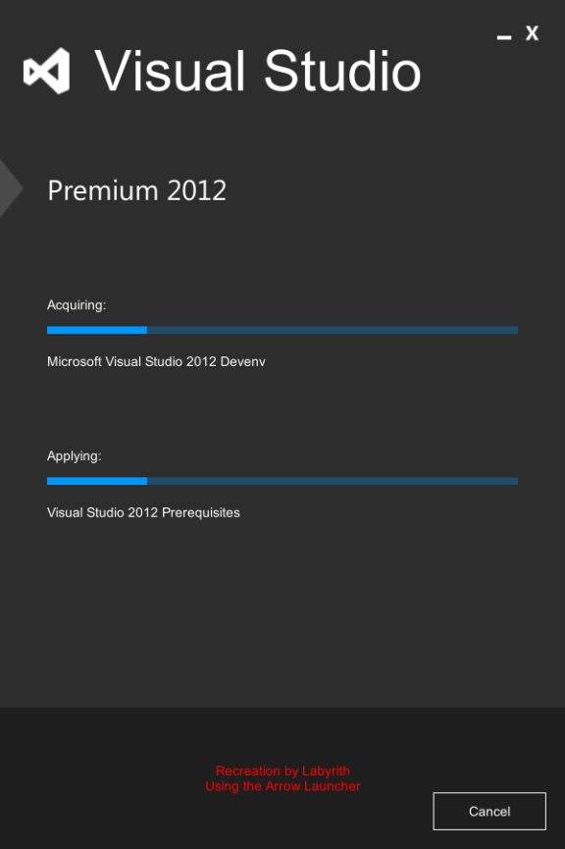**Visual Studio Installer**

In this example, we recreated the Visual Studio 2012 installer from a screenshot during installation, this recreation took about 30 minutes to build in the Unity UI, and 5 minutes to implement functional buttons and links.

For the functionality, we used the UIManager script (see UIManager), this is a Unity UI script for managing button and menu functionality, including hyperlinks, menu switching and application quitting.

All rights to Visual Studio belong to Microsoft.

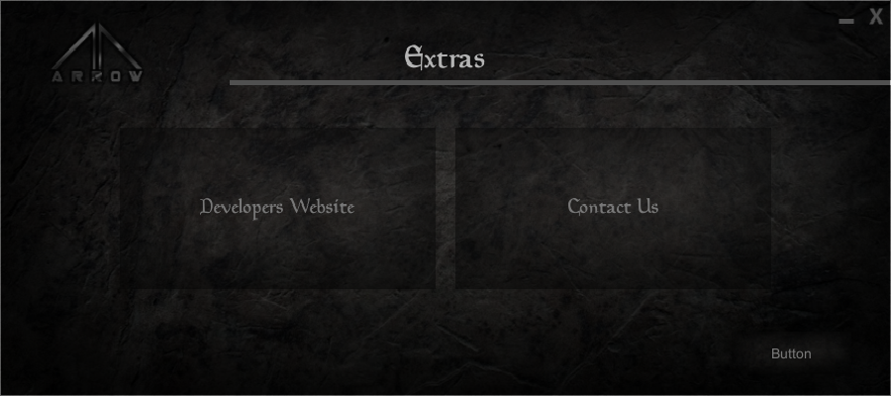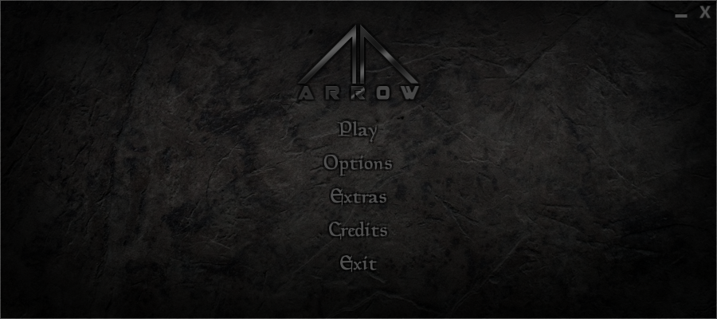**LauncherV1**

This is the main demo for Arrow, it was built in about 1 hour total, and all artwork used in it is included with Arrow Launcher.

This demo is the first to take full advantage of both the Arrow Driver and UIManager, it includes hyperlinks, menu links, website links, application quitting, back buttons and more.

How to make a Launcher

Arrow makes creating launchers in Unity a breeze, and has been laid out as simply as possible, but a few things do need to be explained.

**Step One – Design your Menu**

This is the bit we can’t help you with, this is something you have to decide for yourself.

When using Arrow, most people prefer not to worry about rescaling, as most launchers will fit almost every monitor resolution anyway, this makes designing your launcher much easier.

Make sure you add menu items such as buttons as actual buttons (Right-Click in Hierarchy, UI/Button), and position them how you like.

If you are having issues evenly distributing your buttons, create a Panel (UI/Panel) and place it over the area you wish to contain your buttons, this will act as a bounding box so make sure you have it in the correct place, this can be moved and modified later.

In the Panel, go to “Add Component”, “Layout” and select either “Horizontal Layout Group” or “Vertical Layout Group”, depending on the desired orientation of your menu.

After this, you can child all your buttons to the Panel (drop them in the Hierarchy).

**Step Two – Using UIManager**

The next step is adding your functionality, please not that using UIManager is **NOT** required for using Arrow, it is simply there as a starting point for customers.

Add UIManager to an empty GameObject and set the Menus dropdown to 4, Element 0 is set to accept Main Menu, 1 is set to Options, 2 is set to Extras and 3 is set to Credits, if this is not the order or layout of your menu, some basic modification of UIManager will be required (or you could use your own).

From here, click on a button, at the bottom of the Button component in the Inspector should be an event box called On Click (), click the small + symbol in the bottom corner, you will be presented with a small box, drag the object containing UIManager into the slot.

From the dropdown shown on the right of the box, select UIManager, and the respective effect you want.

|  |  |
| --- | --- |
| **Function** | **Result** |
| ChangeScene() | Allows the button to open a new scene. |
| CreditsMenu() | Switches to the Credits Menu. |
| ExitApp() | This exits/closes the launcher. |
| ExtrasMenu() | Switches to the Extras Menu. |
| LoadWebsite() | This acts in the same way as a hyperlink. |
| MainMenu() | Switches to the Main Menu. |
| MinimiseWindow() | Minimises the window. |
| OpenApplication() | Opens executable at path. |
| OptionsMenu() | Switches to the Options Menu. |

Once you have all your menus set up and working the way you want them to, you can move onto step three.

**Step Three – Setting up the Arrow Window Driver**

We are now going to be building Arrow into our launcher, this controls effects like:

* Removing Windows Borders (cleaner, more professional look)
* Automatic Screen Centring (centres the launcher by default to any resolution)
* Window Dragging (Replaces the dragging functionality removed with borders)
* Launcher Size Override (Force the size of the launcher

We have kept all the main functionality of Arrow in the background to make the script easier to work with, **those new to programming or not familiar with the Windows API should not attempt to edit it.**



In the Arrow Window Driver, the only thing that needs to be set is the intended resolution of your window, the LauncherV1 example uses 900x400, it is best to design the launcher or splash using the same resolution as you set, otherwise some stretching may occur.

The rest of Arrow is controlled from the backend, and this is all you need to do to setup Arrow, from here all you need to do is Build the project to an executable.

**Please note:** Anyone using Unity Personal (Free) will only have Borderless launchers once the “Made with Unity” splash screen has completed, and switched to your launcher.

Legal

**Limited Software License Agreement**

Arrow Launcher 1

Copyright (c) 2015 Don Briggs Ltd

*** END USER LICENSE AGREEMENT ***

IMPORTANT: PLEASE READ THIS LICENSE CAREFULLY BEFORE USING THIS SOFTWARE.

1. LICENSE

By receiving, opening the file package, and/or using Arrow Launcher 1("Software") containing this software, you agree that this End User License Agreement(EULA) is a legally binding and valid contract and agree to be bound by it. You agree to abide by the intellectual property laws and all of the terms and conditions of this Agreement.

Unless you have a different license agreement signed by Don Briggs Ltd your use of Arrow Launcher 1 indicates your acceptance of this license agreement and warranty.

Subject to the terms of this Agreement, Don Briggs Ltd grants to you a limited, non-exclusive, non-transferable license, without right to sub-license, to use Arrow Launcher 1 in accordance with this Agreement and any other written agreement with Don Briggs Ltd. Don Briggs Ltd does not transfer the title of Arrow Launcher 1 to you; the license granted to you is not a sale. This agreement is a binding legal agreement between Don Briggs Ltd and the purchasers or users of Arrow Launcher 1.

If you do not agree to be bound by this agreement, remove Arrow Launcher 1 from your computer now and, if applicable, promptly return to Don Briggs Ltd by mail any copies of Arrow Launcher 1 and related documentation and packaging in your possession.

2. DISTRIBUTION

Arrow Launcher 1 and the license herein granted shall not be copied, shared, distributed, re-sold, offered for re-sale, transferred or sub-licensed in whole or in part except that you may make one copy for archive purposes only. For information about redistribution of Arrow Launcher 1 contact Don Briggs Ltd.

3. USER AGREEMENT

3.1 Use

Your license to use Arrow Launcher 1 is limited to the number of licenses purchased by you. You shall not allow others to use, copy or evaluate copies of Arrow Launcher 1.

3.2 Use Restrictions

You shall use Arrow Launcher 1 in compliance with all applicable laws and not for any unlawful purpose. Without limiting the foregoing, use, display or distribution of Arrow Launcher 1 together with material that is pornographic, racist, vulgar, obscene, defamatory, libellous, abusive, promoting hatred, discriminating or displaying prejudice based on religion, ethnic heritage, race, sexual orientation or age is strictly prohibited.

Each licensed copy of Arrow Launcher 1 may be used on one single computer location by one user. Use of Arrow Launcher 1 means that you have loaded, installed, or run Arrow Launcher 1 on a computer or similar device. If you install Arrow Launcher 1 onto a multi-user platform, server or network, each and every individual user of Arrow Launcher 1 must be licensed separately.

You may make one copy of Arrow Launcher 1 for backup purposes, providing you only have one copy installed on one computer being used by one person. Other users may not use your copy of Arrow Launcher 1 . The assignment, sublicense, networking, sale, or distribution of copies of Arrow Launcher 1 are strictly forbidden without the prior written consent of Don Briggs Ltd. It is a violation of this agreement to assign, sell, share, loan, rent, lease, borrow, network or transfer the use of Arrow Launcher 1. If any person other than yourself uses Arrow Launcher 1 registered in your name, regardless of whether it is at the same time or different times, then this agreement is being violated and you are responsible for that violation!

3.3 Copyright Restriction

This Software contains copyrighted material, trade secrets and other proprietary material. You shall not, and shall not attempt to, modify, reverse engineer, disassemble or decompile Arrow Launcher 1. Nor can you create any derivative works or other works that are based upon or derived from Arrow Launcher 1 in whole or in part.

Don Briggs Ltd's name, logo and graphics file that represents Arrow Launcher 1 shall not be used in any way to promote products developed with Arrow Launcher 1 . Don Briggs Ltd retains sole and exclusive ownership of all right, title and interest in and to Arrow Launcher 1 and all Intellectual Property rights relating thereto.

Copyright law and international copyright treaty provisions protect all parts of Arrow Launcher 1, products and services. No program, code, part, image, audio sample, or text may be copied or used in any way by the user except as intended within the bounds of the single user program. All rights not expressly granted hereunder are reserved for Don Briggs Ltd.

3.4 Limitation of Responsibility

You will indemnify, hold harmless, and defend Don Briggs Ltd , its employees, agents and distributors against any and all claims, proceedings, demand and costs resulting from or in any way connected with your use of Don Briggs Ltd's Software.

In no event (including, without limitation, in the event of negligence) will Don Briggs Ltd , its employees, agents or distributors be liable for any consequential, incidental, indirect, special or punitive damages whatsoever (including, without limitation, damages for loss of profits, loss of use, business interruption, loss of information or data, or pecuniary loss), in connection with or arising out of or related to this Agreement, Arrow Launcher 1 or the use or inability to use Arrow Launcher 1 or the furnishing, performance or use of any other matters hereunder whether based upon contract, tort or any other theory including negligence.

Don Briggs Ltd's entire liability, without exception, is limited to the customers' reimbursement of the purchase price of the Software (maximum being the lesser of the amount paid by you and the suggested retail price as listed by Don Briggs Ltd ) in exchange for the return of the product, all copies, registration papers and manuals, and all materials that constitute a transfer of license from the customer back to Don Briggs Ltd.

3.5 Warranties

Except as expressly stated in writing, Don Briggs Ltd makes no representation or warranties in respect of this Software and expressly excludes all other warranties, expressed or implied, oral or written, including, without limitation, any implied warranties of merchantable quality or fitness for a particular purpose.

3.6 Governing Law

This Agreement shall be governed by the law of the United Kingdom applicable therein. You hereby irrevocably attorn and submit to the non-exclusive jurisdiction of the courts of United Kingdom therefrom. If any provision shall be considered unlawful, void or otherwise unenforceable, then that provision shall be deemed severable from this License and not affect the validity and enforceability of any other provisions.

3.7 Termination

Any failure to comply with the terms and conditions of this Agreement will result in automatic and immediate termination of this license. Upon termination of this license granted herein for any reason, you agree to immediately cease use of Arrow Launcher 1 and destroy all copies of Arrow Launcher 1 supplied under this Agreement. The financial obligations incurred by you shall survive the expiration or termination of this license.

4. DISCLAIMER OF WARRANTY

THIS SOFTWARE AND THE ACCOMPANYING FILES ARE SOLD "AS IS" AND WITHOUT WARRANTIES AS TO PERFORMANCE OR MERCHANTABILITY OR ANY OTHER WARRANTIES WHETHER EXPRESSED OR IMPLIED. THIS DISCLAIMER CONCERNS ALL FILES GENERATED AND EDITED BY Arrow Launcher 1 AS WELL.

5. CONSENT OF USE OF DATA

You agree that Don Briggs Ltd may collect and use information gathered in any manner as part of the product support services provided to you, if any, related to Arrow Launcher 1.Don Briggs Ltd may also use this information to provide notices to you which may be of use or interest to you.